1)***What Is The Total Amount Of Sales?***

select sum(Total_Sales) as Total

from adidassales;

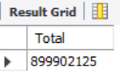

2) ***TOTAL UNITS SOLD***

select sum(Units_Sold) as Total

from adidassales;

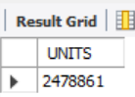

3) ***TOTAL PROFITS***

select sum(Operating_Profit) TOTAL_PROFITS

from adidassales;

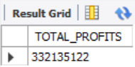

4) ***CITY WISE SALES***

select City as CITY_NAMES, sum(Total_Sales) as SALES

from adidassales

group by City

order by CITY_NAMES;

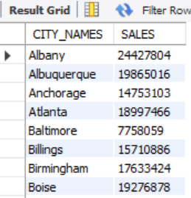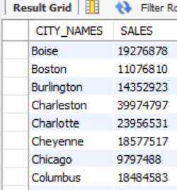  
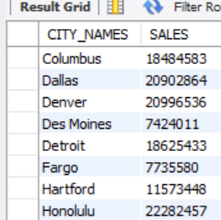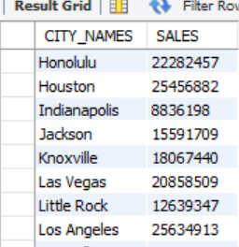

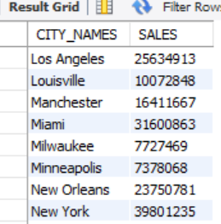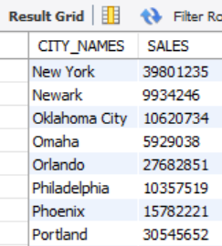  
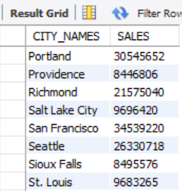 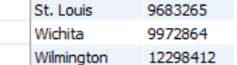

5) ***CITY WISE PROFIT***

select City as CITY_NAMES, sum(Operating_Profit) as PROFIT

from adidassales

group by City

order by CITY_NAMES;

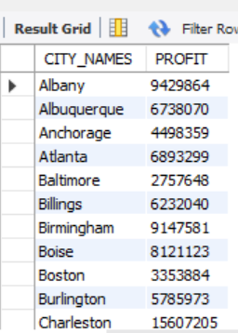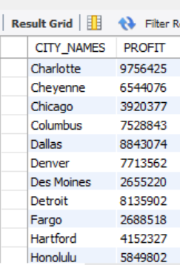

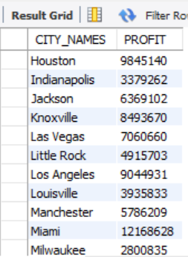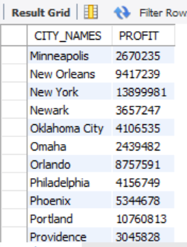

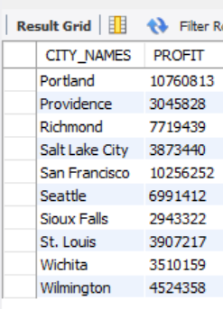

6) ***CITY WISE UNITS SOLD***

select City as CITY_NAMES, sum(Units_Sold) as TOTAL_UNITS

from adidassales

group by City

order by CITY_NAMES;

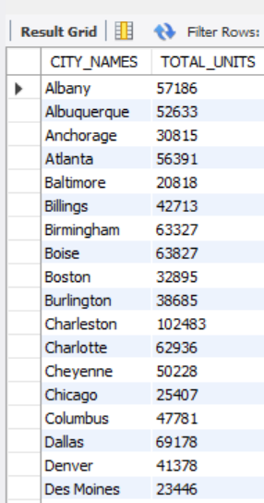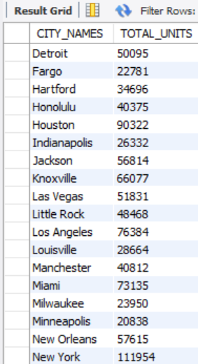

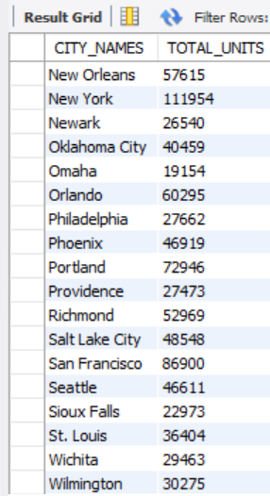

7) ***STATE-WISE UNITS SOLD***

select State as STATE_NAMES, sum(Units_Sold) as TOTAL_UNITS

from adidassales

group by State

order by STATE_NAMES;

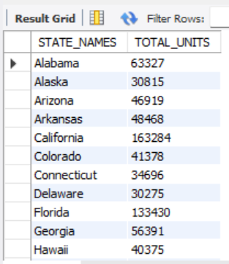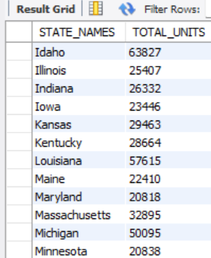  
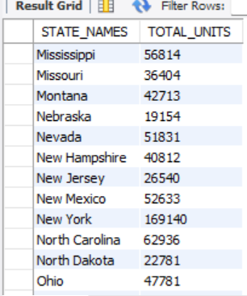 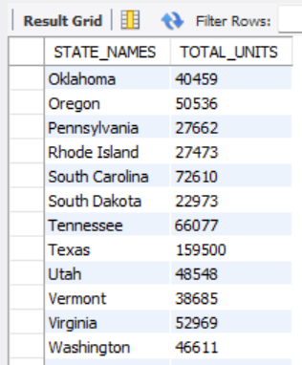

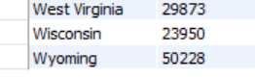

8) ***STATE-WISE PROFITS***

select State as STATE_NAMES, sum(Operating_Profit) as PROFITS

from adidassales

group by State

order by STATE_NAMES;

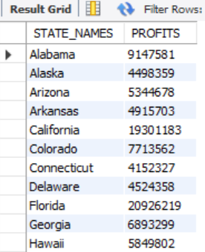 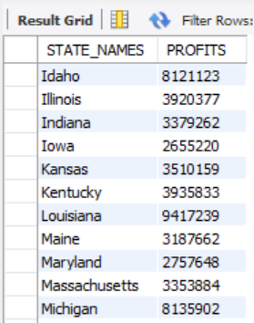

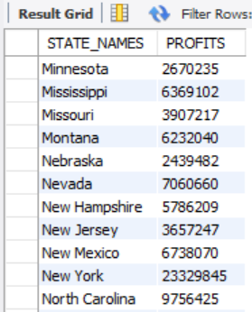 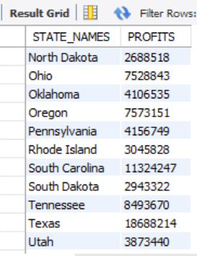

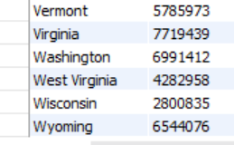

9) ***STATE-WISE SALES***

select State as STATE_NAMES, sum(Total_Sales) as SALES

from adidassales

group by State

order by STATE_NAMES;

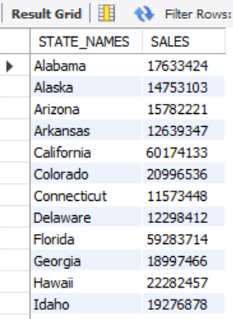 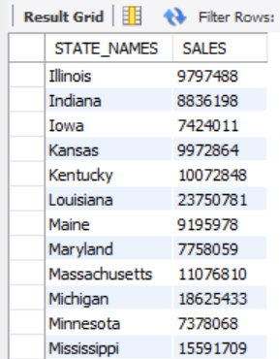

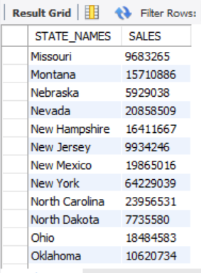 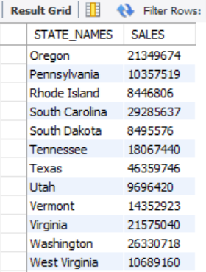



10) ***REGION-WISE SALES***

select Region as REGION_NAMES, sum(Total_Sales) as SALES

from adidassales

group by Region

order by REGION_NAMES;

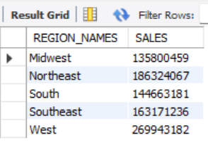

11) ***REGION-WISE PROFITS***

select Region as REGION_NAMES, sum(Operating_Profit) as PROFITS

from adidassales

group by Region

order by REGION_NAMES;

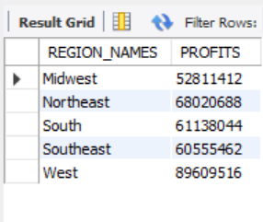

12) ***REGION-WISE UNITS SOLD***

select Region as REGION_NAMES, sum(Units_Sold) as UNITS_SOLD

from adidassales

group by Region

order by REGION_NAMES;

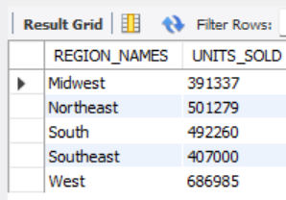

13) ***TOP-5 City IN Units Sold***

select City as City_Names, sum(Units_Sold) as UNITS

from adidassales

group by City

order by UNITS DESC

limit 5;

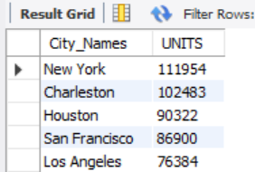

14) ***TOP-5 City IN Sales***

select City as City_Names, sum(Total_Sales) as SALES

from adidassales

group by City

order by SALES DESC

limit 5;

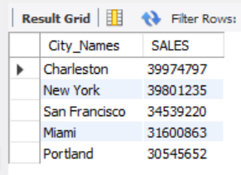

15) ***TOP-5 City IN Profits***

select City as City_Names, sum(Operating_Profit) as PROFITS

from adidassales

group by City

order by PROFITS DESC

limit 5;

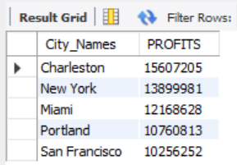

16) ***TOP 5 State In profits***

select State as State_Names, sum(Operating_Profit) as PROFITS

from adidassales

group by State

order by PROFITS DESC

limit 5;

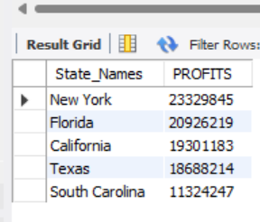

17) ***TOP 5 State In Units Sold***

select State as State_Names, sum(Units_Sold) as UNITS_SOLD

from adidassales

group by State

order by UNITS_SOLD DESC

limit 5;

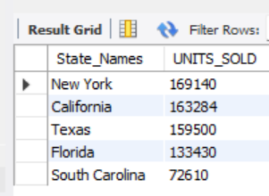

18***) TOP 5 State In Sales***

select State as State_Names, sum(Total_Sales) as SALES

from adidassales

group by State

order by SALES DESC

limit 5;

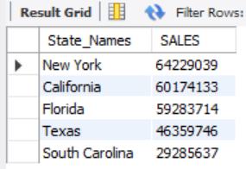

19) ***LEAST 5 States In Sales***

select State as State_Names, sum(Total_Sales) as SALES

from adidassales

group by State

order by SALES

limit 5;

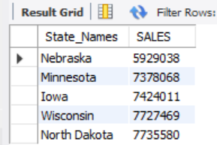

20) ***LEAST 5 States In Profits***

select State as State_Names, sum(Operating_Profit) as PROFITS

from adidassales

group by State

order by PROFITS

limit 5;

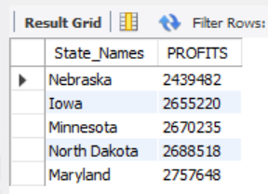

21) ***LEAST 5 States In Units Sold***

select State as State_Names, sum(Units_Sold) as UNITS

from adidassales

group by State

order by UNITS

limit 5;

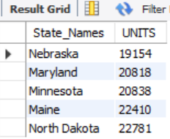

22) ***Product wise units***

select Product, sum(Units_Sold) as Products_Sold

from adidassales

group by Product;

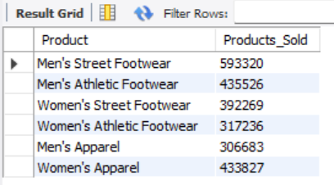

23) ***PROFIT PERCENTAGE OF EACH SALES METHOD***

**A)** **ONLINE**

select

((select sum(Operating_Profit)

from adidassales

where Sales_Method = 'Online') / sum(Operating_Profit) * 100) as Online_Profit_Percentage

from adidassales;

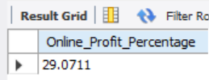

**B) IN-STORE**

select

((select sum(Operating_Profit)

from adidassales

where Sales_Method = 'In-store') / sum(Operating_Profit) * 100) as Instore_Profit_Percentage

from adidassales;

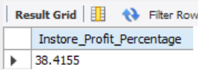

**C) OUTLETS**

select

((select sum(Operating_Profit)

from adidassales

where Sales_Method = 'Outlet') / sum(Operating_Profit) * 100) as Outlet_Profit_Percentage

from adidassales;

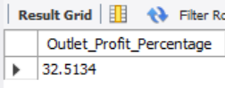

24) ***SALES PERCENTAGE OF EACH SALES METHOD***

**A) ONLINE**

select

((select sum(Total_Sales)

from adidassales

where Sales_Method = 'Online') / sum(Total_Sales) * 100) as Online_Sales_Percentage

from adidassales;

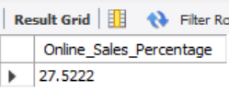

**B) IN-STORE**

select

((select sum(Total_Sales)

from adidassales

where Sales_Method = 'In-store') / sum(Total_Sales) * 100) as In_Store_Sales_Percentage

from adidassales;

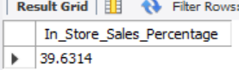

**C) OUTLETS**

select

((select sum(Total_Sales)

from adidassales

where Sales_Method = 'Outlet') / sum(Total_Sales) * 100) as Outlet_Sales_Percentage

from adidassales;

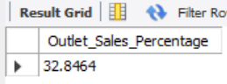

25) ***GENDER WISE SALES PERCENTAGE***

**A) WOMEN**

select

((select sum(Total_Sales)

from adidassales

where Product in ("Women's Street Footwear","Women's Athletic Footwear","Women's Apparel")) / sum(Total_Sales) * 100) as Women_Sales_Percentage

from adidassales;

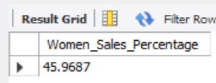

**B) MEN**

select

((select sum(Total_Sales)

from adidassales

where Product in ("Men's Street Footwear","Men's Athletic Footwear","Men's Apparel")) / sum(Total_Sales) * 100) as Men_Sales_Percentage

from adidassales;

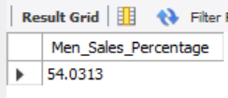

26) ***GENDER WISE PROFIT PERCENTAGE***

**A) WOMEN**

select

((select sum(Operating_Profit)

from adidassales

where Product in ("Women's Street Footwear","Women's Athletic Footwear","Women's Apparel")) / sum(Operating_Profit) * 100) as Women_Profit_Percentage

from adidassales;

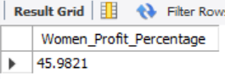

**B) MEN**

select

((select sum(Operating_Profit)

from adidassales

where Product in ("Men's Street Footwear","Men's Athletic Footwear","Men's Apparel")) / sum(Operating_Profit) * 100) as Men_Profit_Percentage

from adidassales;

